Merise et base de donnee

Lalaniaina CFP

**EXERCICE 1**

**MCD:**

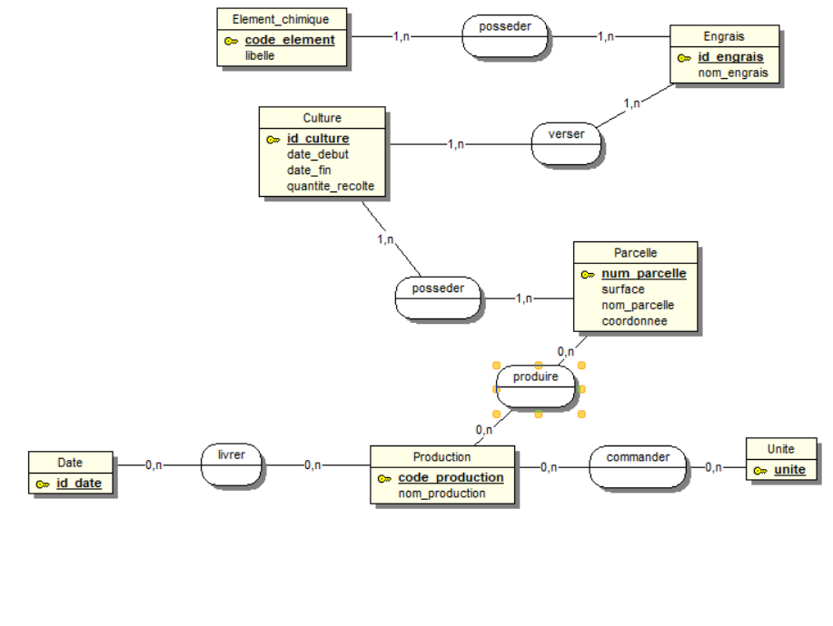

**MLD**:

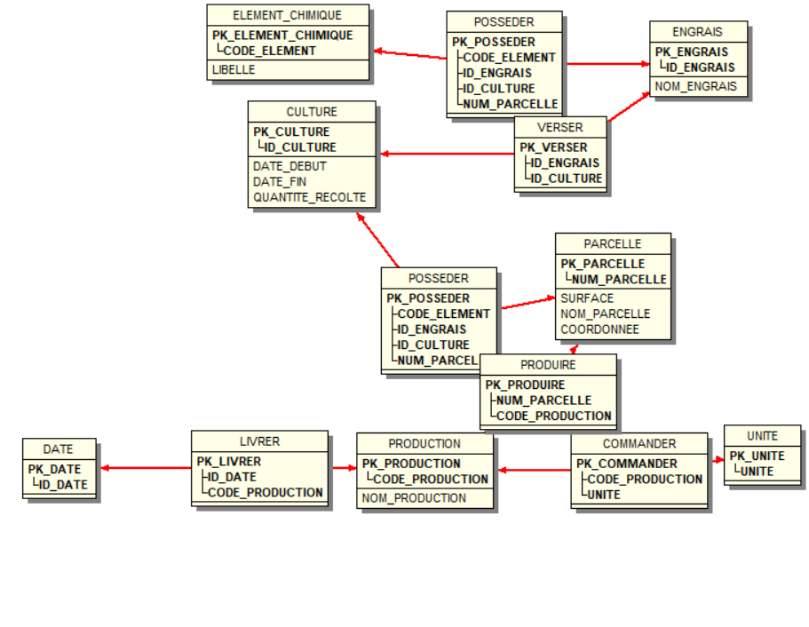

**SQL**

DROP DATABASE IF EXISTS MLR2;

CREATE DATABASE IF NOT EXISTS MLR2;

USE MLR2;

# -----------------------------------------------------------------------------

# TABLE : CULTURE

# -----------------------------------------------------------------------------

CREATE TABLE IF NOT EXISTS CULTURE

(

ID_CULTURE CHAR(32) NOT NULL ,

DATE_DEBUT DATE NULL ,

DATE_FIN DATE NULL ,

QUANTITE_RECOLTE INTEGER(2) NULL

, PRIMARY KEY (ID_CULTURE)

)

comment = "";

# -----------------------------------------------------------------------------

# TABLE : DATE

# -----------------------------------------------------------------------------

CREATE TABLE IF NOT EXISTS DATE

(

ID_DATE DATE NOT NULL

, PRIMARY KEY (ID_DATE)

)

comment = "";

# -----------------------------------------------------------------------------

# TABLE : UNITE

# -----------------------------------------------------------------------------

CREATE TABLE IF NOT EXISTS UNITE

(

UNITE CHAR(32) NOT NULL

, PRIMARY KEY (UNITE)

)

comment = "";

# -----------------------------------------------------------------------------

# TABLE : PARCELLE

# -----------------------------------------------------------------------------

CREATE TABLE IF NOT EXISTS PARCELLE

(

NUM_PARCELLE INTEGER(2) NOT NULL ,

SURFACE INTEGER(2) NULL ,

NOM_PARCELLE CHAR(255) NULL ,

COORDONNEE CHAR(255) NULL

, PRIMARY KEY (NUM_PARCELLE)

)

comment = "";

# -----------------------------------------------------------------------------

# TABLE : PRODUCTION

# -----------------------------------------------------------------------------

CREATE TABLE IF NOT EXISTS PRODUCTION

(

CODE_PRODUCTION SMALLINT(1) NOT NULL ,

NOM_PRODUCTION CHAR(255) NULL

, PRIMARY KEY (CODE_PRODUCTION)

)

comment = "";

# -----------------------------------------------------------------------------

# TABLE : ELEMENT_CHIMIQUE

# -----------------------------------------------------------------------------

CREATE TABLE IF NOT EXISTS ELEMENT_CHIMIQUE

(

CODE_ELEMENT CHAR(32) NOT NULL ,

LIBELLE CHAR(255) NULL

, PRIMARY KEY (CODE_ELEMENT)

)

comment = "";

# -----------------------------------------------------------------------------

# TABLE : ENGRAIS

# -----------------------------------------------------------------------------

CREATE TABLE IF NOT EXISTS ENGRAIS

(

ID_ENGRAIS INTEGER(2) NOT NULL ,

NOM_ENGRAIS CHAR(255) NULL

, PRIMARY KEY (ID_ENGRAIS)

)

comment = "";

# -----------------------------------------------------------------------------

# TABLE : COMMANDER

# -----------------------------------------------------------------------------

CREATE TABLE IF NOT EXISTS COMMANDER

(

CODE_PRODUCTION SMALLINT(1) NOT NULL ,

UNITE CHAR(32) NOT NULL

, PRIMARY KEY (CODE_PRODUCTION,UNITE)

)

comment = "";

# -----------------------------------------------------------------------------

# INDEX DE LA TABLE COMMANDER

# -----------------------------------------------------------------------------

CREATE INDEX I_FK_COMMANDER_PRODUCTION

ON COMMANDER (CODE_PRODUCTION ASC);

CREATE INDEX I_FK_COMMANDER_UNITE

ON COMMANDER (UNITE ASC);

# -----------------------------------------------------------------------------

# TABLE : LIVRER

# -----------------------------------------------------------------------------

CREATE TABLE IF NOT EXISTS LIVRER

(

ID_DATE DATE NOT NULL ,

CODE_PRODUCTION SMALLINT(1) NOT NULL

, PRIMARY KEY (ID_DATE,CODE_PRODUCTION)

)

comment = "";

# -----------------------------------------------------------------------------

# INDEX DE LA TABLE LIVRER

# -----------------------------------------------------------------------------

CREATE INDEX I_FK_LIVRER_DATE

ON LIVRER (ID_DATE ASC);

CREATE INDEX I_FK_LIVRER_PRODUCTION

ON LIVRER (CODE_PRODUCTION ASC);

# -----------------------------------------------------------------------------

# TABLE : POSSEDER

# -----------------------------------------------------------------------------

CREATE TABLE IF NOT EXISTS POSSEDER

(

CODE_ELEMENT CHAR(32) NOT NULL ,

ID_ENGRAIS INTEGER(2) NOT NULL ,

ID_CULTURE CHAR(32) NOT NULL ,

NUM_PARCELLE INTEGER(2) NOT NULL

, PRIMARY KEY (CODE_ELEMENT,ID_ENGRAIS,ID_CULTURE,NUM_PARCELLE)

)

comment = "";

# -----------------------------------------------------------------------------

# INDEX DE LA TABLE POSSEDER

# -----------------------------------------------------------------------------

CREATE INDEX I_FK_POSSEDER_ELEMENT_CHIMIQUE

ON POSSEDER (CODE_ELEMENT ASC);

CREATE INDEX I_FK_POSSEDER_ENGRAIS

ON POSSEDER (ID_ENGRAIS ASC);

CREATE INDEX I_FK_POSSEDER_CULTURE

ON POSSEDER (ID_CULTURE ASC);

CREATE INDEX I_FK_POSSEDER_PARCELLE

ON POSSEDER (NUM_PARCELLE ASC);

# -----------------------------------------------------------------------------

# TABLE : VERSER

# -----------------------------------------------------------------------------

CREATE TABLE IF NOT EXISTS VERSER

(

ID_ENGRAIS INTEGER(2) NOT NULL ,

ID_CULTURE CHAR(32) NOT NULL

, PRIMARY KEY (ID_ENGRAIS,ID_CULTURE)

)

comment = "";

# -----------------------------------------------------------------------------

# INDEX DE LA TABLE VERSER

# -----------------------------------------------------------------------------

CREATE INDEX I_FK_VERSER_ENGRAIS

ON VERSER (ID_ENGRAIS ASC);

CREATE INDEX I_FK_VERSER_CULTURE

ON VERSER (ID_CULTURE ASC);

# -----------------------------------------------------------------------------

# TABLE : PRODUIRE

# -----------------------------------------------------------------------------

CREATE TABLE IF NOT EXISTS PRODUIRE

(

NUM_PARCELLE INTEGER(2) NOT NULL ,

CODE_PRODUCTION SMALLINT(1) NOT NULL

, PRIMARY KEY (NUM_PARCELLE,CODE_PRODUCTION)

)

comment = "";

# -----------------------------------------------------------------------------

# INDEX DE LA TABLE PRODUIRE

# -----------------------------------------------------------------------------

CREATE INDEX I_FK_PRODUIRE_PARCELLE

ON PRODUIRE (NUM_PARCELLE ASC);

CREATE INDEX I_FK_PRODUIRE_PRODUCTION

ON PRODUIRE (CODE_PRODUCTION ASC);

# -----------------------------------------------------------------------------

# CREATION DES REFERENCES DE TABLE

# -----------------------------------------------------------------------------

ALTER TABLE COMMANDER

ADD FOREIGN KEY FK_COMMANDER_PRODUCTION (CODE_PRODUCTION)

REFERENCES PRODUCTION (CODE_PRODUCTION) ;

ALTER TABLE COMMANDER

ADD FOREIGN KEY FK_COMMANDER_UNITE (UNITE)

REFERENCES UNITE (UNITE) ;

ALTER TABLE LIVRER

ADD FOREIGN KEY FK_LIVRER_DATE (ID_DATE)

REFERENCES DATE (ID_DATE) ;

ALTER TABLE LIVRER

ADD FOREIGN KEY FK_LIVRER_PRODUCTION (CODE_PRODUCTION)

REFERENCES PRODUCTION (CODE_PRODUCTION) ;

ALTER TABLE POSSEDER

ADD FOREIGN KEY FK_POSSEDER_ELEMENT_CHIMIQUE (CODE_ELEMENT)

REFERENCES ELEMENT_CHIMIQUE (CODE_ELEMENT) ;

ALTER TABLE POSSEDER

ADD FOREIGN KEY FK_POSSEDER_ENGRAIS (ID_ENGRAIS)

REFERENCES ENGRAIS (ID_ENGRAIS) ;

ALTER TABLE POSSEDER

ADD FOREIGN KEY FK_POSSEDER_CULTURE (ID_CULTURE)

REFERENCES CULTURE (ID_CULTURE) ;

ALTER TABLE POSSEDER

ADD FOREIGN KEY FK_POSSEDER_PARCELLE (NUM_PARCELLE)

REFERENCES PARCELLE (NUM_PARCELLE) ;

ALTER TABLE VERSER

ADD FOREIGN KEY FK_VERSER_ENGRAIS (ID_ENGRAIS)

REFERENCES ENGRAIS (ID_ENGRAIS) ;

ALTER TABLE VERSER

ADD FOREIGN KEY FK_VERSER_CULTURE (ID_CULTURE)

REFERENCES CULTURE (ID_CULTURE) ;

ALTER TABLE PRODUIRE

ADD FOREIGN KEY FK_PRODUIRE_PARCELLE (NUM_PARCELLE)

REFERENCES PARCELLE (NUM_PARCELLE) ;

ALTER TABLE PRODUIRE

ADD FOREIGN KEY FK_PRODUIRE_PRODUCTION (CODE_PRODUCTION)

REFERENCES PRODUCTION (CODE_PRODUCTION) ;

**EXERCICE 2**

1.Sans utiliser DISTINCT

a/

SELECT Num_Client

FROM Compte

WHERE solde < 1000

UNION

SELECT Num_Client

FROM Compte

WHERE solde > 100000;

2.

a/

SELECT Num_Client FROM CLIENT WHERE NUM_Client NOT IN ( SELECT Num_Client FROM COMPTE WHERE Num_Agence IN ( SELECT Num_Agence FROM COMPTE WHERE Num_Client IN ( SELECT Num_Client FROM CLIENT WHERE Nom = ‘Bettencourt AND Prenom = ‘Liliane’;

b/

SELECT Num_Agence

FROM AGENCE

WHERE Actif > All ( SELECT Actif FROM AGENCE WHERE Ville = ‘Saint-Ouen’);

c/

SELECT Num_Agence, AVG(Solde) AS Solde_Moyen FROM COMPTE GROUP BY Num_Agence Having AVG(Solde) > 10000;

3.1)  
CREATE TABLE Privilege (

id INT PRIMARY KEY,

nomTable VARCHAR(255),

idUtilisateur INT,

droit ENUM('SELECT', 'INSERT', 'UPDATE', 'DELETE', 'ALL'),

FOREIGN KEY (nomTable) REFERENCES Table(nomTable),

FOREIGN KEY (idUtilisateur) REFERENCES Utilisateur(id)

);

3.2)

CREATE TABLE Privilege (

id INT PRIMARY KEY,

nomTable VARCHAR(255),

idUtilisateur INT,

droit ENUM('SELECT', 'INSERT', 'UPDATE', 'DELETE', 'ALL'),

FOREIGN KEY (nomTable) REFERENCES Table(nomTable),

FOREIGN KEY (idUtilisateur) REFERENCES Utilisateur(id)

);

3.3)

SELECT Utilisateur.nom, Utilisateur.prenom

FROM Utilisateur

JOIN Table ON Utilisateur.id = Table.idCreateur

GROUP BY Utilisateur.id

HAVING COUNT(*) = (

SELECT MAX(tableCount)

FROM (

SELECT COUNT(*) AS tableCount

FROM Table

GROUP BY idCreateur

) AS Counts

);